Our Ontario turtles are semi-aquatic; while they spend a lot of time in the water, they also travel on land a lot too. They will be on the move any time from April to October, although the busiest time for them is May and June. Both males and females travel, and both are equally vulnerable to road mortality (the OTCC consistently sees 50:50 males to females in all species except the map turtle).
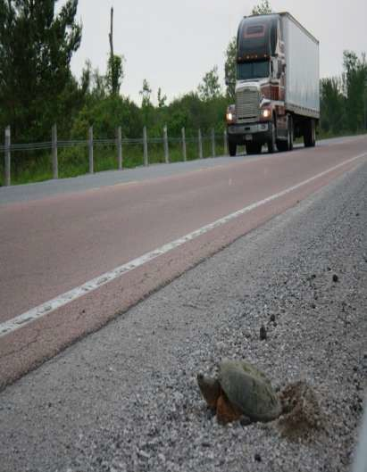

Females travel the most in June, as this is their most important time for laying eggs. They look for appropriate sites to lay their eggs, and often travel large distances to find them. Each species has their own preference and preferred time for laying eggs. Laying eggs involves the female digging a hole (very slowly, in true turtle style!) and depositing the eggs, and then covering them up. There is no parental care of the eggs beyond this, and the hatchlings are on their own to find their way to water. Unfortunately, they don’t always choose the best site…
Turtle eggs act as food for a great many wild species, and only a very small percent (less than 1%) ever make into the population. In fact, it takes about 59 years for a snapping turtle to have a hope of replacing itself in the population, since they mature so late, and so few eggs survive!
While populations can sustain this loss of eggs and hatchlings when no other unnatural threats are placed on them, all of Ontario species are now considered Species at Risk, due to the many human-related threats. As a result, they need all the help they can get to attempt to offset this.
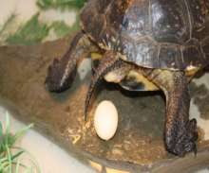

Many conservation initiatives are underway across the province, to help tip the balance back and allow populations to survive.
Protection of the adults is obviously the most important conservation initiative, but there are additional programs that can also help to sustain populations.
Nest Protection
Nest protection programs are underway by biologists across the province, to increase the survival of the eggs, and hatchlings. It is not legal to disturb or interfere with a natural nest in any way, without the appropriate permits through the Ministry of Natural Resources and Forestry (MNRF). However, the MNRF does allow nest protection on private property, carried out by the property owner.
If property owners decide to do this, it is very important that no harm is done in the process- eggs and hatchlings can be put under even more risk, with improper nest protection devices.
Since most of our Ontario species of turtles have “temperature dependent sex determination” i.e., the temperature of incubation affects the sex of the turtles, it is very important that the temperature of the nest is not interfered with, by materials that shade the site. Also, it is very important that the hatchlings have access to escape, since you may not be there when they hatch, and they can succumb very quickly without an escape route. (within 20 minutes in some cases!)
DYI Nest protection tips
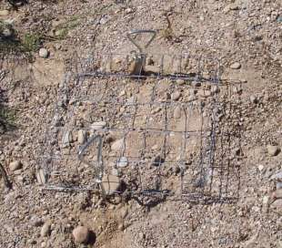

The easiest device to use for your property, involves wide mesh wire, raised above the nest, to allow movement of hatchlings, and secured adequately into the ground to prevent predators digging it up. (See photo above).
For those who are a bit handy, a more elaborate device involves a wood frame with narrower gage mesh, staked securely into the ground.
Bricks or rocks can also be placed on the edges of the frame to make it even more secure from predation.

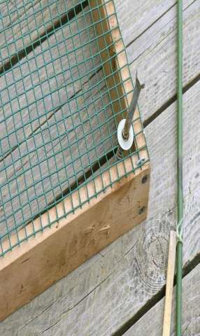
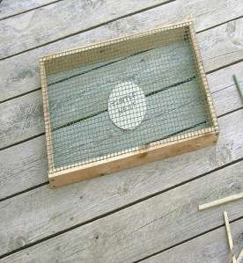
A wooden frame is made and covered with wire mesh. (see photo above).
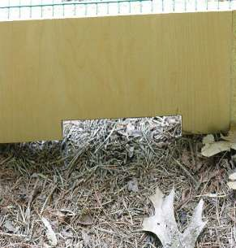

IT IS VERY IMPORTANT THAT THERE ARE ESCAPE ROUTES CUT OUT OF THE FRAME, WITH THIS METHOD.
Without these, the hatchlings have no means to escape after hatching, and can quickly die. The escape routes cut into the wooden frame must be big enough for the hatchlings to leave once hatched.
(As an alternative, you may remove the nest cover after a month or two when the scent of the nesting turtle will have dissipated and before the turtle hatchings emerge after about 90 days gestation.)
Stake the device as shown, to prevent movement of the nest cage by a predator, but make sure the stakes do not disturb the nest itself. (In Long Point, we also include a six-inch wide skirt of wire mesh around the outer sides of the frame as a further deterrent to digging by predators).

